Prevention Peer Network
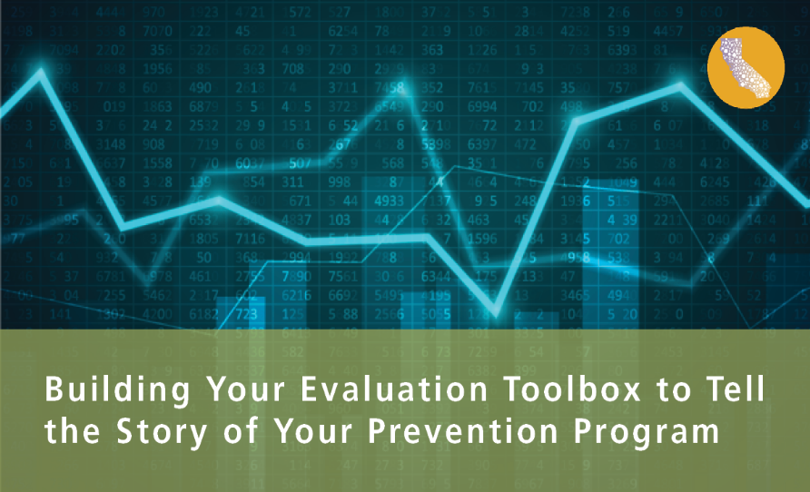
August 15, 2019

RESOURCES

EVALUATION PLANNING
- EvaluACTION. Veto Violence, CDC
https://vetoviolence.cdc.gov/apps/evaluaction/
- Community Toolbox. University of Kansas
https://ctb.ku.edu/en/table-of-contents/overview/model-for-community-change-and-improvement/evaluation-model/main
- Evaluation Toolkit. NSVRC
https://www.nsvrc.org/prevention/evaluation-toolkit
- Planning & Evaluation Workbook. Strategic Prevention Solutions
https://www.strategicpreventionsolutions.com/product/planning-and-evaluation-workbook/
- Content Crosswalk, Choosing Measures Decision Tree and other worksheets shared in webinar. Strategic Prevention Solutions
https://www.strategicpreventionsolutions.com/resources/
- Logic Model Development Guide. W.K Kellogg Foundation
https://www.wkkf.org/resource-directory/resource/2006/02/wk-kellogg-foundation-logic-model-development-guide

DATA COLLECTION
- California’s RPE Outcome Evaluation Survey Indicators & Community Outcomes Form.
Contact Mina White, CDPH Mina.White@cdph.ca.gov
- Creative Ways to Solicit Stakeholder Feedback: Visual, Verbal, and Kinesthetic Approaches to Gather Input from any Audience. By Public Profit
https://www.publicprofit.net/Creative-Ways-To-Solicit-Stakeholder-Feedback

DATA ANALYSIS & REPORTING
- Survey Monkey
https://www.surveymonkey.com/
- Survey Gizmo
https://www.surveygizmo.com/
- Dedoose
https://www.dedoose.com/
- MS Excel

